Pakistan J. Zool., vol. 43(3), pp. 469-472, 2011.

Dysdercus evanescens Distant. (Hemiptera: Pyrrhocoridae) and its Phylogenetic Relationships

Syed Salahuddin Qadri,¹ *and Imtiaz Ahmad²
¹Department of Zoology, Jamia Millia Government Degree College, Malir, Karachi, Pakistan
²Dr. Afzal Hussain Qadri Biological Research Center, University of Karachi, Karachi-75270.

Abstract.- A cotton stainer species Dysdercus evanescens Distant is redescribed in detail with special reference to its metathoracic scent auricle, male genitalia including inflated aedeagus and female genitalia including spermatheca. In this light its phylogenetic relationship is also briefly discussed within its subgenus Paradysdercus Stehlik.

Key words: Dysdercus evanescens, genitalia, Hemiptera, Pyrrhocoridae, phylogeny.

INTRODUCTION

Freeman (1947) revised the genus Dysdercus Guérin Méneville from old world, the pests of malvacian plants, mainly cotton. He described Dysdercus evanescens Distant from Sikkim, Assam, Bengal, and Bombay Presidensy in India, Burma and Indo-China and gave only illustration of vertical process. He gave brief description of its pygophore suggesting resemblance of its paramere and its spermatheca with D. koenigii (F.). Freeman (op. cit.) categorised the genus Dysdercus in four groups and was probably the first to group the Dysdercus species on the basis of more reliable characters of male and female genitalia particularly the spermatheca. He split the old world species into two groups on the basis of presence or absence of vertical process of pygophore. In the first group without this process he placed all Ethiopian species excluding D. festivus Gerstaecker and further divided group I into two groups.
In the second group having vertical process Freeman (op. cit.) placed (except the only Ethiopian species D. festivus) the Oriental, Australasian, Australomalayan and Oceanic species. He further divided group II into two groups i.e. II a on the basis of second conjunctival appendages of aedeagus simple unbranched, spermathecal duct relatively
_________________________
* Part of the Ph. D. thesis of first author.
** Corresponding author: iahmad3141@yahoo.com
0030-9923/2011/0003-0469 $ 8.00/0
Copyright 2011 Zoological Society of Pakistan.
only a little or entirely uncoiled and accessory gland recurved comprising D. rosaceus Ahmad and Qadri, D. koenigii (F.), D. solenis (Herrich-Schäffer), D. evanescens Distant, D. olivaceus (F.) D. similis Freeman, D. poecilus (Herrich-Schäffer), D. transversalis Blöte, D. concinnulus Walker D. festivus Gerstaecker, D. cingulatus (F.), D. sidae Montrouzier and D. longiceps Breddin. Freeman (op.cit.) separated his group II b on the basis of second conjunctival appendages of aedeagus forked, spermathecal bulb pear shaped and accessory gland balloon shaped, swollen and straight.
Kapur and Vazirani (1960) followed Freeman (1947) and Stehlik (1965) formally named these species groups, i.e., I(a) and (b) and II(a) and (b) as independent subgenera i.e. Dysdercus s. str., Neodysdercus Stehlik, Paradysdercus Stehlik and Megadysdercus Breddin of equal status adding characters of the paramere and all conjunctival appendages. However, his parameral characters are not clear cut and show numerous variations. Dysdercus evanescens Distant is placed in Paradysdercus Stehlik on the basis of second conjunctival appendages of aedeagus simple, spermathecal duct relatively only a little or uncoiled and accessory gland re-curved. It is described here in detail with special reference to mostly unknown characters, i.e. metathoracic scent auricle, male genitalia including inflated aedeagus and female genitalia including spermatheca and in this light its relationship within its group is also briefly discussed, particularly differentiating it from its closest ally.
MATERIALS AND METHODS

Holotype female with three male and 13 female specimens lodged at Natural History Museum, London (BMNH), were borrowed from the above museum by the courtesy of Mr. Mick Webb in-charge Hemiptera section of that museum for examination.
For the study of male genitalia particularly for the inflation of the aedeagus the techniques of Ahmad (1986) and Ahmad and McPherson (1990, 1998) were generally followed. For the inflation of aedeagus the pinned dry specimen after removing the label, was plunged into boiling water in a beaker, for 4-5 minutes for softening. The specimen was then slipped of the pin. The genital capsule (Pygophore) was removed from the relaxed specimen under a binocular microscope, using very fine watch maker forceps (5 or finer). The genital capsule was placed in 10% KOH and was warmed at 40ºC for 5-10 minutes in a cavity block. The capsule was removed in tap water (room temperature) in a depression dish and was washed thoroughly. The vesica was then pulled out gently. This was done very care fully because the distal tip of vesica is very delicate and breaks off quickly.
For the dissection of the female spermatheca, the entire abdomen was warmed on a bench lamp (after completing the external view diagram of the ovipositor) for 15 minutes. The spermatheca was dissected out in tap water after washing the specimen thoroughly. The components of male and female genitalia were preserved in glycerin in micro-vials pinned with the specimens. All measurements given are in millimeters and all illustrations are to the given scales.

RESULTS

Dysdercus evanescens Distant
(Figs. 1 – 2)

Dysdercus evanescens Distant 1902: 43; 1904: 120; Bergroth 1913: 173; Hussey 1929: 89; Blöte 1931: 121; Freeman 1947: 402-403.
Astemma evanescens Kirkaldy and Edwards 1902: 172;

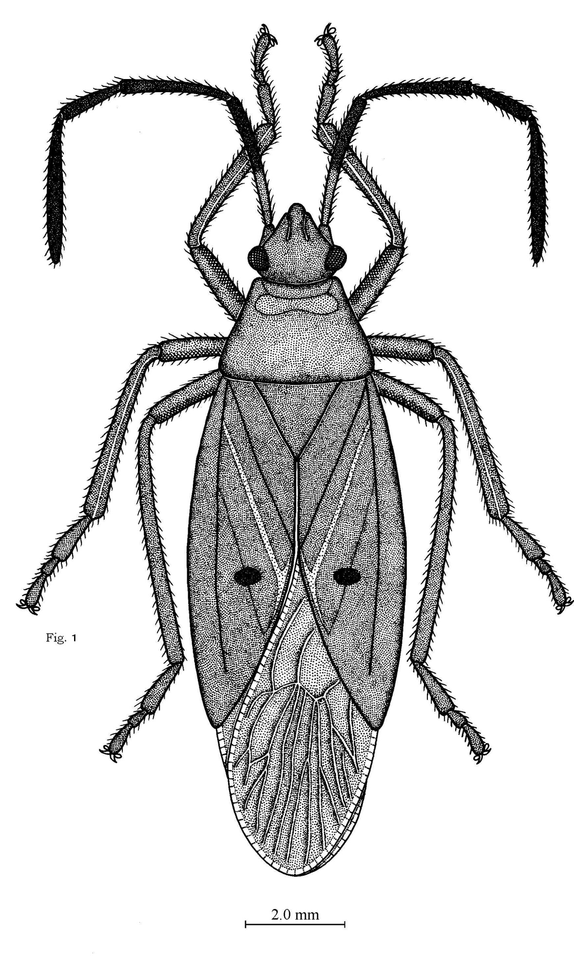

Fig. 1. Dysdercus evanescens Distant

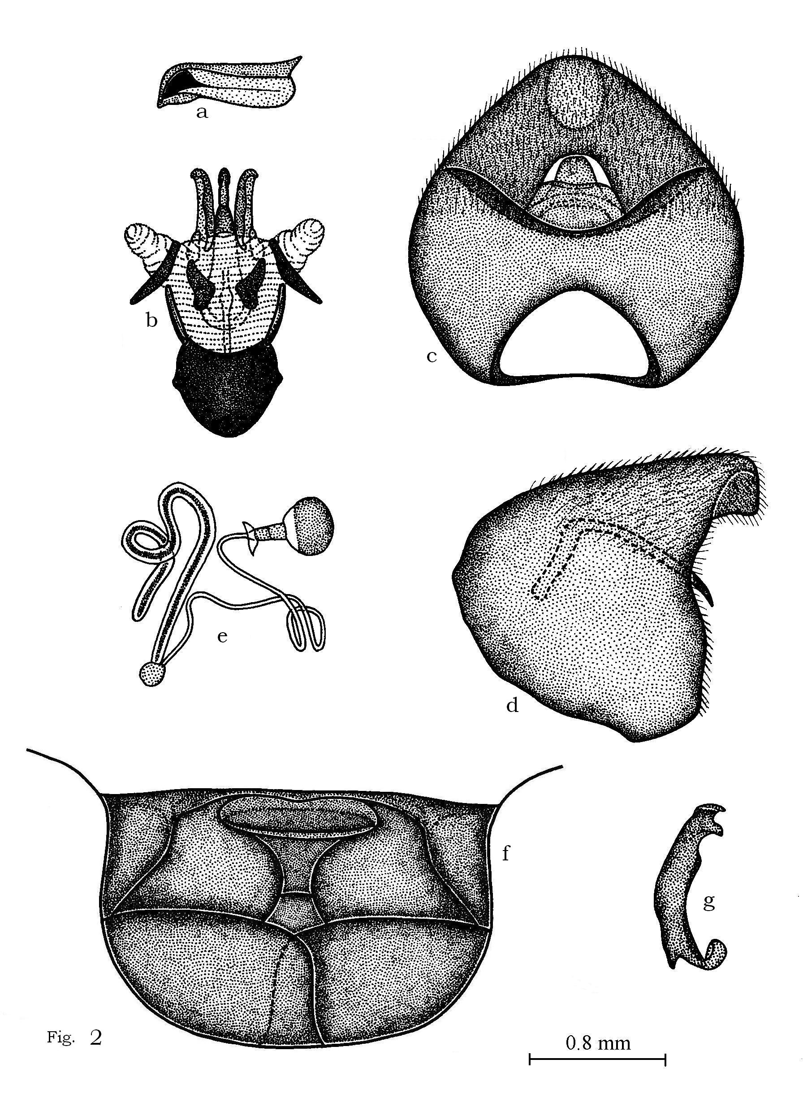

Fig. 2. Dysdercus evanescens a. metathoracic scent gland ostiolar peritreme, ventral view; b, inflated aedeagus, dorsal view; c, pygophore, dorsal view; d, pygophore, lateral view; e, spermatheca, lateral view; f, female terminalia, ventral view g,; paramere, inner view.

Colouration
Body pale tinged reddish, except antennae, eyes, a small rounded spot on middle of each corium castaneous; head, legs, callosities of pronotum reddish; anterior margin of pronotum, tip of scutellum white; membrane of hemelytra-dull white.

Head
Anteocular distance about 1¼x posterior of head including eyes, length of head slightly shorter than its width; length of head 1.8, width 1.9; second antennal segment about 1½x the length of third, length of segments I 2.5 (1.5-3.2), II 1.9 (1.9-2.1), III 1.2 (1.2-1.5), IV 2.7 (2.7-3.6), antennal formula 3 < 2 < 1<4; labium reaching to third abdominal venter, basal segment equal to length of second, distinctly more than the length of third, length of segments I 1.8 (1.8-2.4), II 1.8 (1.8-2.4), III 1.3 (1.3-2.1), IV 1.2 (1.2-1.7); labial formula 4<3<1=2; length anteocular distance 1.0(1.0-1.2); length posterior of head including eyes 0.8(0.8-0.9); intrerocular distance 0.9(0.9-1.1).

Thorax
Width of pronotum distinctly more than one 1½x of its length, anterior angles of pronotum subrounded, lateral margin concave, length of pronotum 2.1 (2.1-3.2), width 3.6 (3.6-4.8); scutellum slightly broader than long, length of scutellum 1.4 (1.4-1.7), width 1.6 (1.6-2.1); metathoracic scent gland ostiolar peritreme (Fig. 2a) large lobe-like with apex broad; distance base scutellum-apex clavus 3.1 (3.1-4.2); apex clavus-apex corium 3.5 (3.5-5.1); apex corium-apex abdomen including membrane 8.0 (0.811.4). Total length male 13.3, female 14.2.

Male genitalia
Pygophore (Figs. 2c and d) somewhat ovate, slightly broader than long dorso-posterior margin deeply concave, ventro-posterior margin deeply concave, ventro-posterior margin narrowly rounded and convex, arms of vertical process stripe like, tip bluntly rounded; paramere (Fig. 2g) curved with three tooth-like projections, two on inner side and one on outer side, inner tooth large, outer tooth short; inner margin humped, outer margin medially convex; inflated aedeagus (Fig. 2b) with narrowed and elongated dorso-lateral membranous conjunctival appendages and pair of large curved hook-like third conjunctival appendages, pair of plate-like second conjunctival appendages pair of broad plate-like first conjunctival appendages.

Female genitalia (Fig. 2f)
First gonocoxae large, broad with posterior margin somewhat convex; ninth paratergites large, somewhat triangular and much longer than eighth paratergites; second gonocoxae with truncated posterior margin; proctiger broad with posterior margin concave; spermatheca (Fig. 2e) with prominent proximal flange, bulb somewhat spherical, pump region large, tube-like, spermathecal duct relatively longer and highly convoluted, accessory gland twisted, tube-like.

Material examined
Holotype female India, Assam, 12-5-1924, leg Mag. RW.G. Hingstow, W. F. Badgley, lodged at BMNH. 3 male, 13 female, Bombay, Bengal, Sikhim, 1914, 1924, at BMNH.

Comparative note
This species is most closely related to D. rosaceus Ahmad and Qadri (2007) in appearance, with corium pale ochraceous or deep red, concolorous with head, callus, pronotum and scutellum and corial spots like small dot with pale membrane but it can easily be separated from it in having parameral second tooth truncated and first gonocoxae with proximal angle concave in contrast to rosaceus having parameral second tooth beak like and first gonocoxae with proximal angles rounded.

DISCUSSION

The apomorphy of relatively short spermathecal duct and tube like spermathecal gland, broadly long arms of vertical process and paramere with three teeth like processes closely relate concinnulus, evanescens, festivus, koenigii, olivaceus, poecilus, rosaceus, similis, solenis and transversalis. In this complex of species concinnulus appears to be entirely isolated playing out group relationship with the rest of clade. The species rosaceus, evanescens, koenigii and olivaceus (Fig. 3) appear isolated and playing outgroup relationships with the rest of the species of Paradysdercus in having the apomorphy of pygophoral ventral rim upturned with apex bilobate and vertical process not medially broad. Thus rosaceus and evanescens appear to play sister group relationship with each other and outgroup relationship with koenigii and olivaceus in having the apomorphy of corial spots small, dot like with membrane pale (Fig. 3) . The species evanescens appears isolated from rosaceus in having apomorphy of first gonocoxae with proximal angle concave in contrast to rounded in rosaceus and parameral second tooth truncated in contrast to beak like in rosaceus.

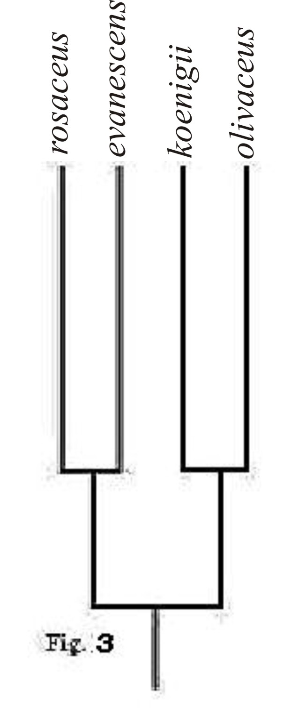

Fig. 3. Cladogram showing phylogenetic relationship of Dysdercus evanescens

REFERENCES

AHMAD, I., 1986. A fool proof Technique for inflation of male geitalia in Hemiptera (Insecta). Pak. J. Ent., Karachi, 1: 111-112.
AHMAD, I. AND MCPHERSON, J.E., 1990. Male genitalia of the type species of Coriomelaena White, Cydnoides Malloch and Galgupha Amyot and Serville (Hemiptera: Cydnidae: Coriomelaeninae) and their bearing on classification. Ann. entomol. Soc. Am., 83: 162-170.
AHMAD, I. AND MCPHERSON, J. E., 1998. Additional information on male and female genitalia of Parabrochymena Lariviere and Brochymena Amyot and Serville (Hemiptera: Pentatomidae). Ann. entomol. Soc. Am., 91: 800-807.
AHMAD, I. AND QADRI, S.S., 2007. A new specie of Dysdercus Guérin Méneville. (Hemiptera: Pyrrhocoridae) from Bhutan with special reference to its genitalia and its relationships. Pakistan J. Zool., 39: 375-378.
BERGROTH, E., 1913. Supplementum Catalogi Heteropterorum Bruxellensis. II. Mem. Soc. Ent. Belg., 22: 125-183.
BLÖTE, H.C., 1931. Catalogue of the Pyrrhocoridae in’s Rijks Museum van Natuurlijke Historie. Zool. Meded. (Leiden) 14: 97-136.
DISTANT, W.L., 1902. Rhynchotal Notes XII. Family Pyrrhocoridae. Ann. Mag. Nat. Hist. 9: 34-45.
DISTANT, W.L., 1904. The fauna of British India, Rhynchota, etc. Taylor and Francis, London Pyrrhocoridae, Vol. II.
FREEMAN, P., 1947. A revision of the genus Dysdercus Boisduval (Hemiptera: Pyrrhocoridae), excluding the American species. Trans. R. ent. Soc. London, 98: 373-424, 59 figs.
HUSSEY, R.F., 1929. Pyrrhocoridae General catalogue of the Hemiptera. Part III, 144 pp. Smith coll., North Hampton, Mass, USA.
KAPUR, A. P. AND VAZIRANI, T. G., 1960. The identity and geographical distribution of the Indian species of the genus Dysdercus Boisduval (Hemiptera: Pyrrhocoridae). Rec. Indian Mus., 54: 107-150. (1956)
KIRKALDY, G.W. AND EDWARDS, S., 1902. Anmerkungen über bemerkenswerte Pyrrhocorinen (Rhynchota). Wien. ent. Ztg., 21: 161-172.
STEHLIK, J. L., 1965. Pyrrhocoridae and Largidae collected by E. S. Brown on Solomon Island (Heteroptera). Acta Mus. Moraviae. Sci. nahuales vedy Prirodni, 50: 253-292.

(Received 28 April 2010, revised September 27, 2010)

